Name: Ashok Rathod

Lab: Constraints

Date: 4.16.19

2. for Identity columns as primary key for all table with seed 100 and increment by 2

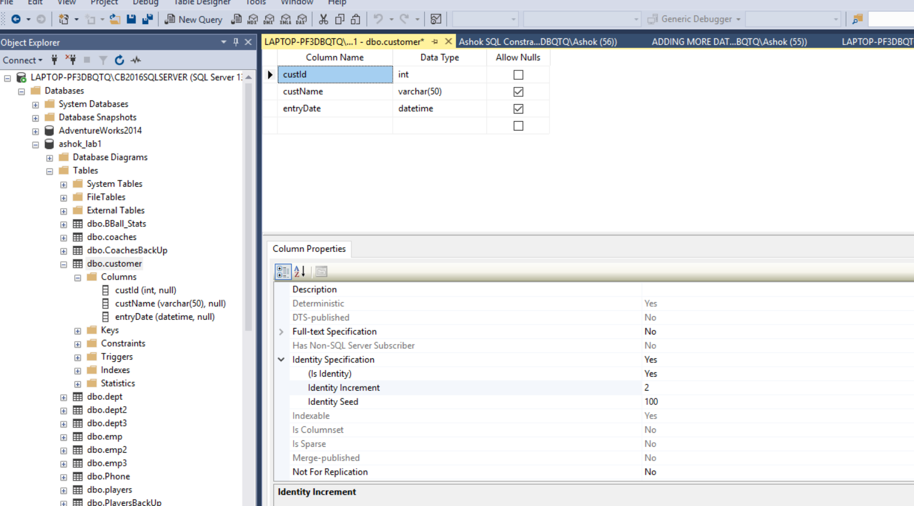

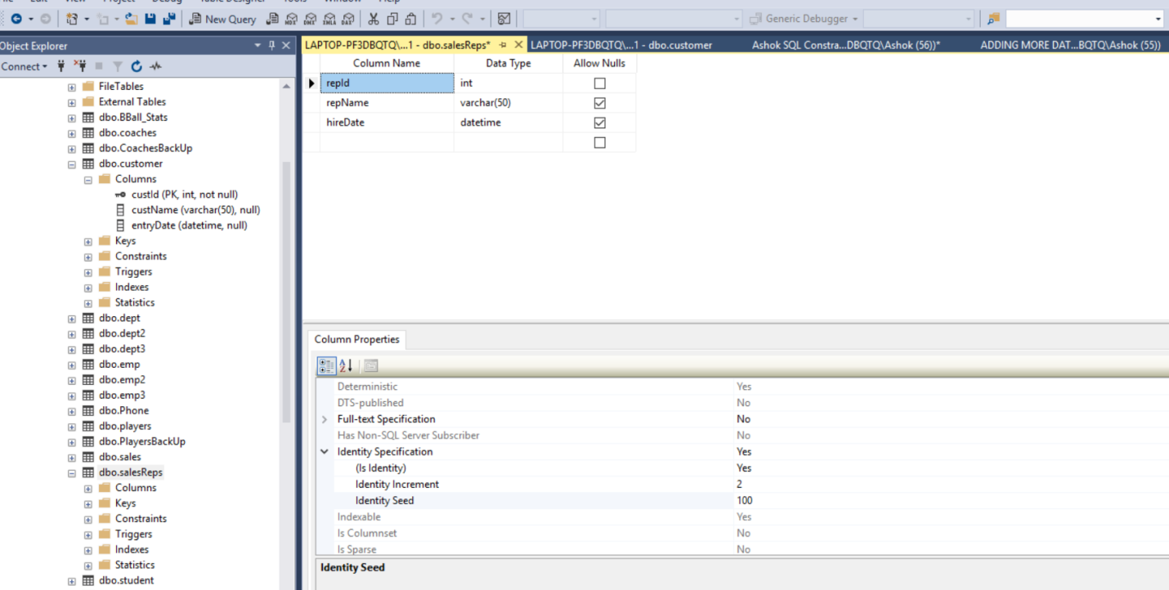

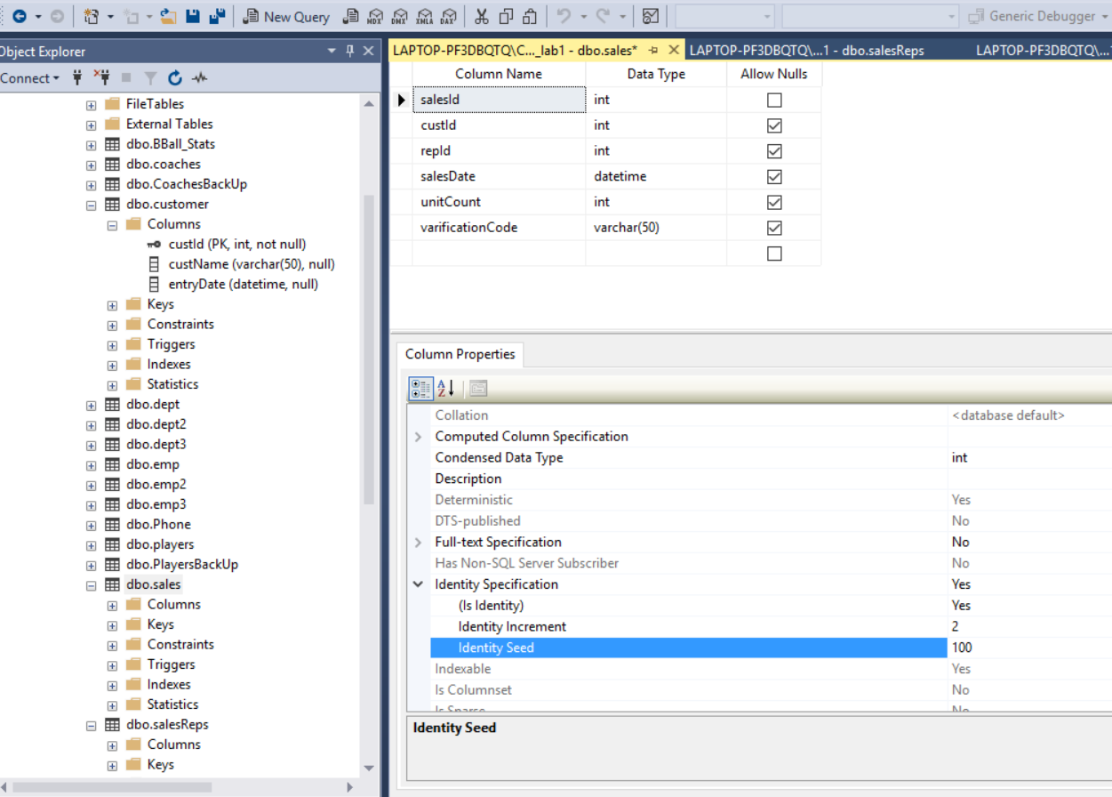

/\*5. No nulls will be allowed in the following tables.columns

a. dbo.Sales.SalesDate ---- done with Query

b. dbo.Sales.VerificationCode\*/ -- GUI way

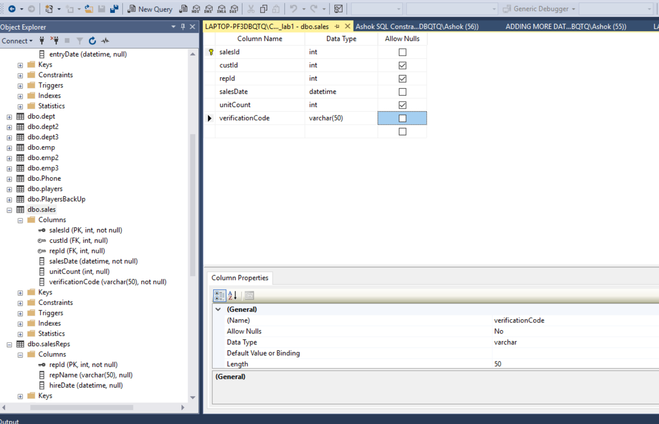

Group Session

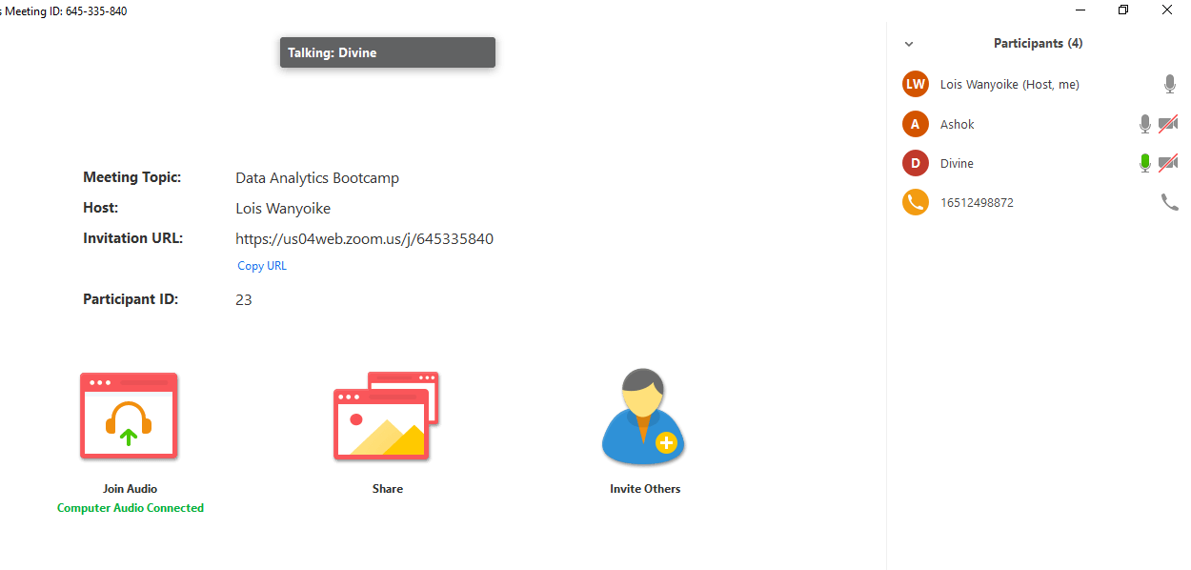

Divine – Working on Constraints

DJ – Working on Constraints

Ashok – Working on Constraints

Lois – Working on Constraints